**QUEUEING SIMULATOR**

**GitHub Link: https://github.com/umerfarooq777/OR-Final-Project**

**Deployed Link:** [**https://or-simulator.netlify.app/**](http://queuing-simulator.surge.sh/)

**INTRODUCTION**:

In this simulation, we will be monitoring the efficiency and performance of the queue. We have implemented the M/M/C queuing model, a mathematical representation of a queue system, to analyse and understand the behaviour of the customer’s queue. By using this model, we aim to provide insights into the potential bottlenecks and areas for improvement in the queue management process.

**APPLICATION VIEW OF STARTING PAGE:**

**Home Page:**

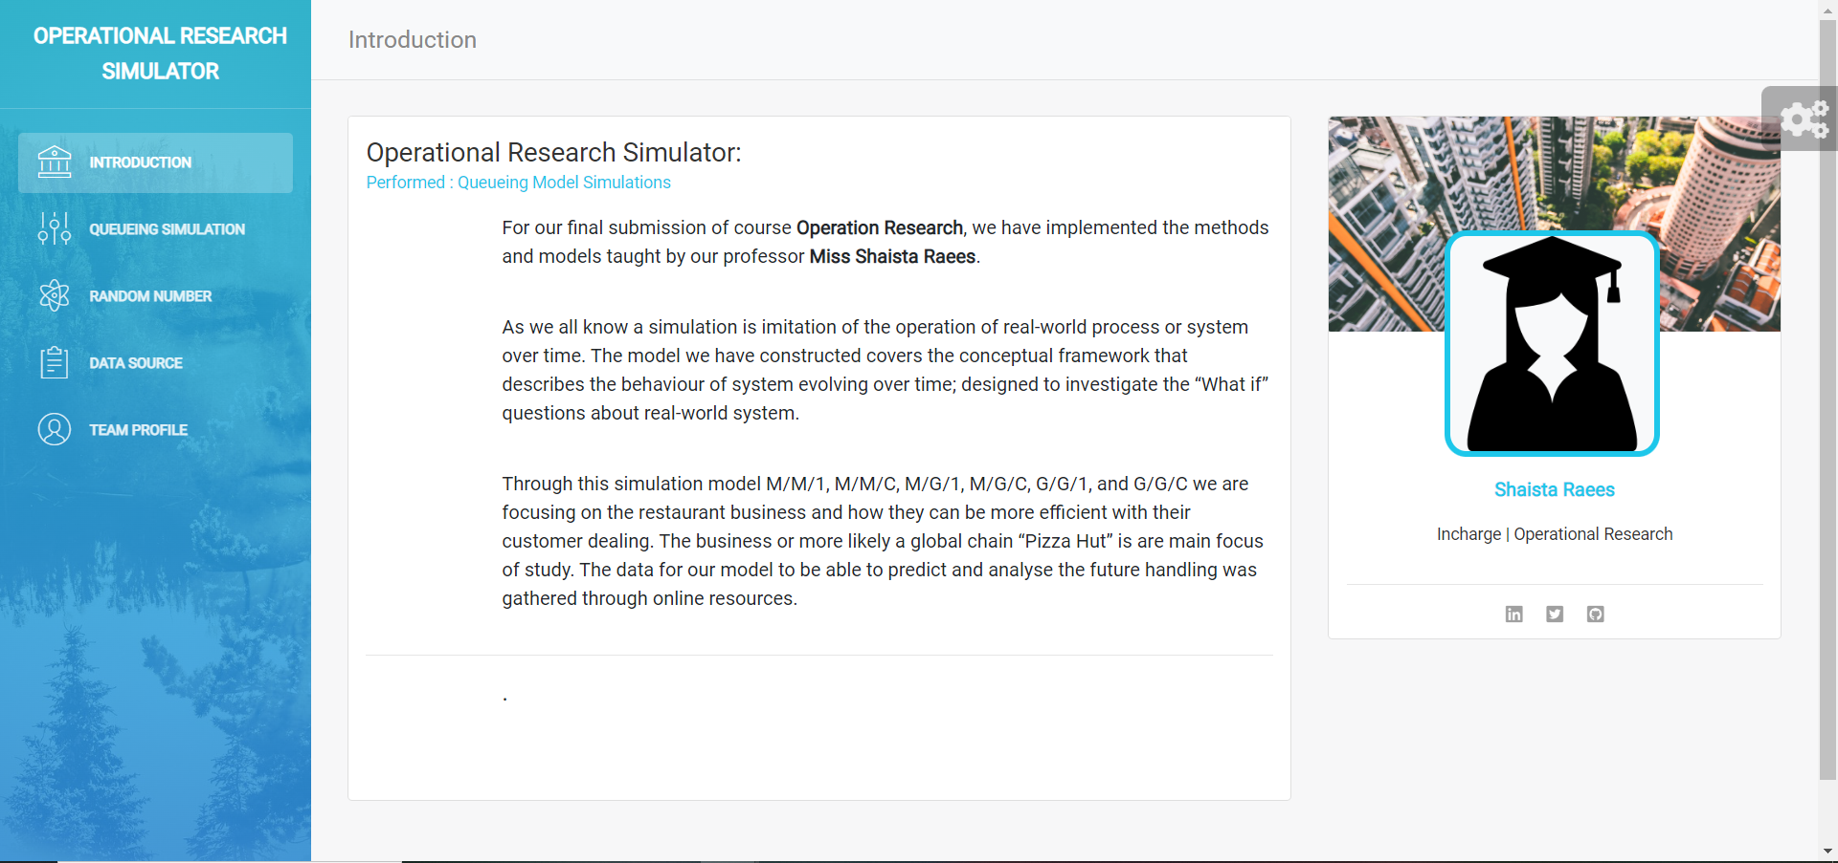

This is the home page of our simulator in this page on the left side of the header we have to option one is to find the tabular values, graph and performance measure on the basis of no of servers by a given data. In the second icon we find all those things that we define in the first option by using the excel file.

Now, we come to a home page. First, we choose a number of servers maximum limit is 6. In the centre, we have two portions one for Arrival time and the second is Service time. In the first portion, we have multiple fields:

**Arrival Time Distribution:**

In this field, we choose the option which operation we need to perform like exponential, uniform, gamma and normal distribution.

**Mean of Inter Arrival Time**

In this field we input an Inter arrival time in the means form.

**Variance of Inter arrival**

In this field we pass an input of variance of inter arrival time. We pass this value at that time when we choose uniform, normal or gamma distribution otherwise the field is disappeared.

In the second portion:

**Service Time Distribution**

In this field, we choose the option which operation we need to perform like exponential, uniform, gamma and normal distribution.

**Mean of Service Time**

In this field we input a service time in the means form.

**Variance of Service Time**

In this field, we pass an input of variance of service time. We pass this value from different perspectives. Like if we select uniform, normal or gamma distribution in the arrival time distribution the exponential option is hidden in the service time distribution field, if we select uniform, normal or gamma distribution in the arrival time distribution and also select uniform, normal or gamma distribution in the service time distribution then we pass the values of the variance on both the arrival and service time fields and also if we select exponential distribution in the arrival time distribution and select uniform, normal or gamma distribution in the service time distribution then the field of arrival time distribution is disappeared and we input only variance in the service time distribution.

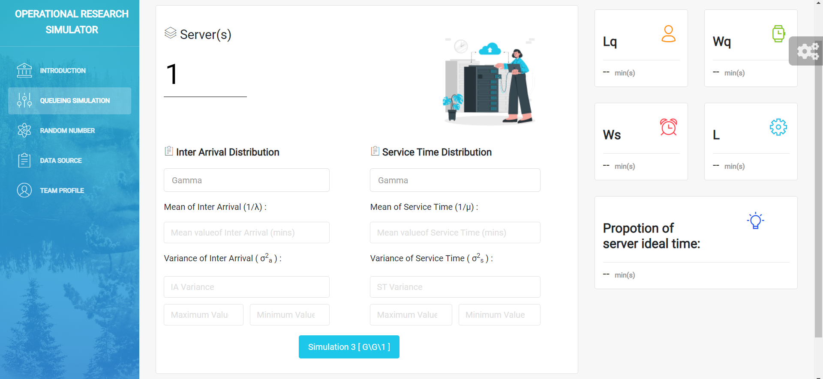

After all these processes, we can get the output of the performance measure. Like,

* Mean Number of Customers in the Queue(Lq)
* Mean waiting time in the Queue(Wq)
* Mean waiting time in the System(W)
* Mean Number of Customers in the System(L)
* Proposition of Time the Server is idle

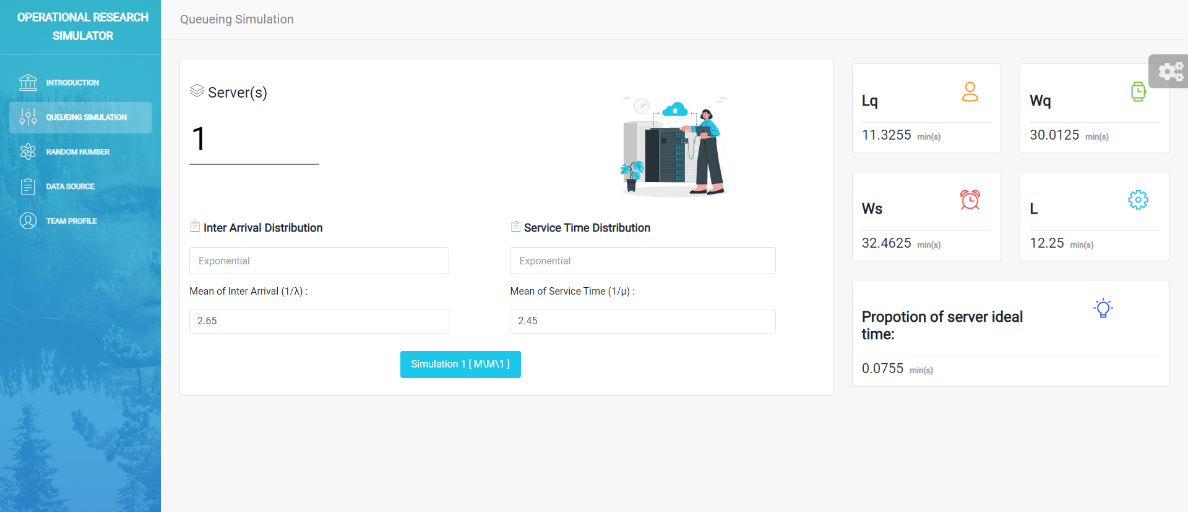

**Graph Page:**

In this page we have for fields one is mean of lambda where we enter a value in a minute, another is mean of meu where we enter a value in a minute, in the third field we can enter a number of customers with the number of customers we can show a data on a customer wise and in the graph the data is shown by customer wise, and last we can select a server and calculate them.

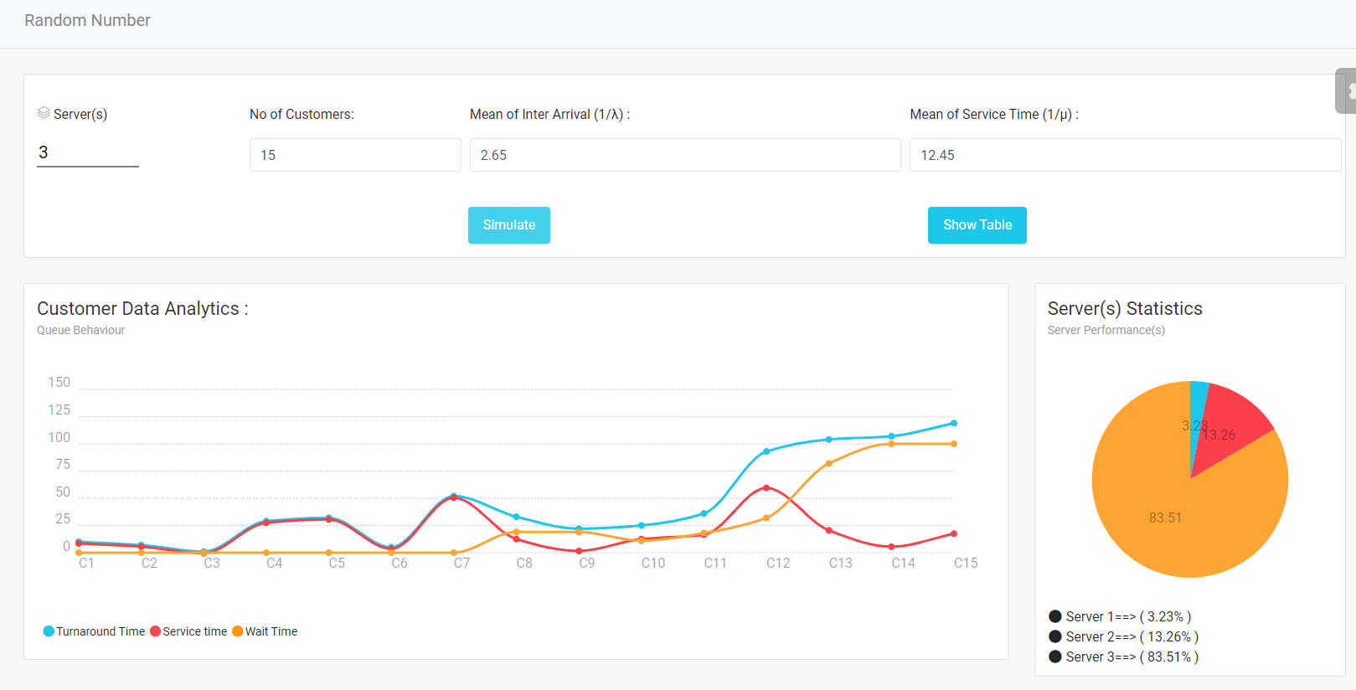

After click on calculate button, we can see we have three partitions one is Tabular form data, second is Graphs and third where we calculate performance measures depends on a server.

**Tabular Form:**

In the table, we have nine columns for customers where the data calculated for each customer, arrival time, service time, start time where the customer time starts, end time where the customer time ends, turnaround time that we calculate by end time minus arrival time, a response time that we calculate by start time minus ka arrival time, the wait time is calculated by turnaround time minus ka service time and last we have server assign column where we assign server by priority wise.

**Graph:**

In the graph, we draw a graph in a minute by using service time, turnaround time and wait time. In the x-axis, we have a number of customers and y-axis we have a time in a minute. In the graph blue line shows turnaround time, green line show wait time and red line service time.

**Performance Measure:**

In this portion we calculate performance measure by the size of servers. In the performance measure portion, we calculate average arrival time, average service time, average turnaround time, average wait time, average response time and average wait time for those who wait.

**Data Upload Page:**

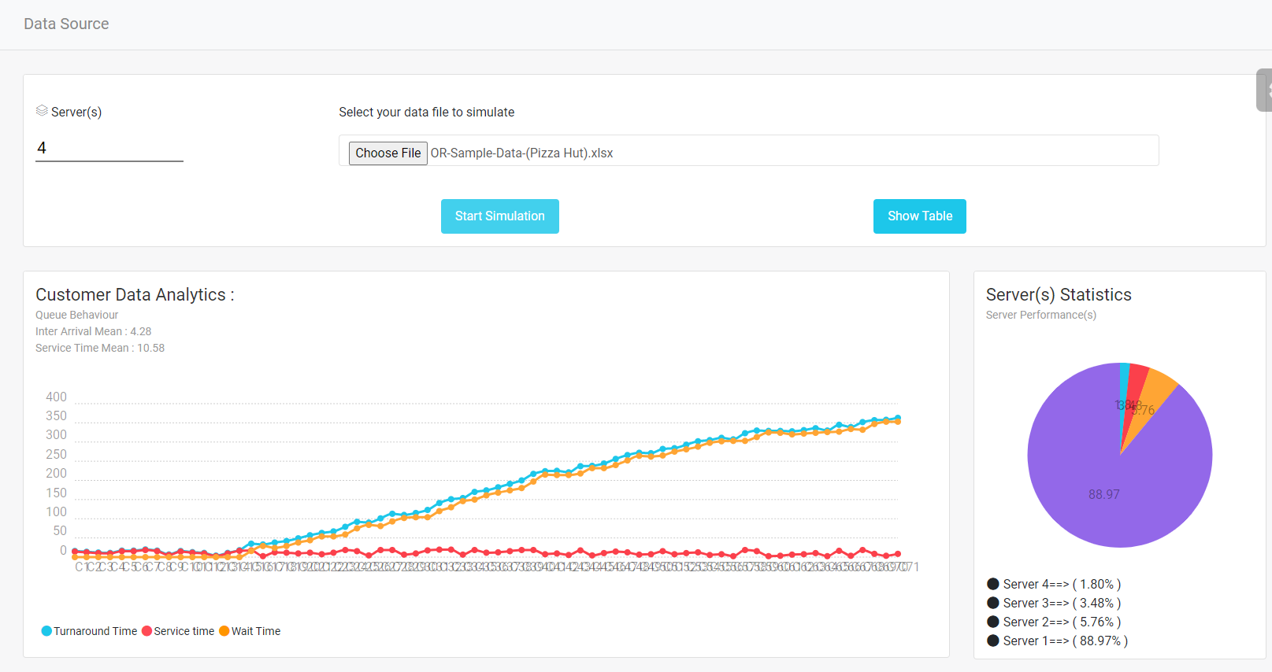This is the page where we will run the same process as last, but one thing is different, we give data in an xlsx form. For this file we have some specific formats like the first column must be customers, the second column is arrival time and third column is service time.

In this page, we have multiple portions. In the first portion where we choose a data file, the Number of servers field is where we can define how much server data we want.

After click on calculate button, we can see we have three partitions one is Tabular form data, second is Graphs and third where we calculate performance measures depends on a server.

**Tabular Form:**

In the table, we have nine columns for customers where the data calculated for each customer, arrival time, service time, start time where the customer time starts, end time where the customer time ends, turnaround time that we calculate by end time minus arrival time, a response time that we calculate by start time minus ka arrival time, the wait time is calculated by turnaround time minus ka service time and last we have server assign column where we assign server by priority wise.

**Graph:**

In the graph, we draw a graph in a minute by using service time, turnaround time and wait time. In the x-axis, we have a number of customers and y-axis we have a time in a minute. In the graph blue line shows turnaround time, green line show wait time and red line service time.

**Performance Measure:**

In this portion we calculate performance measure by the size of servers. In the performance measure portion, we calculate average arrival time, average service time, average turnaround time, average wait time, average response time and average wait time for those who wait.

Data:

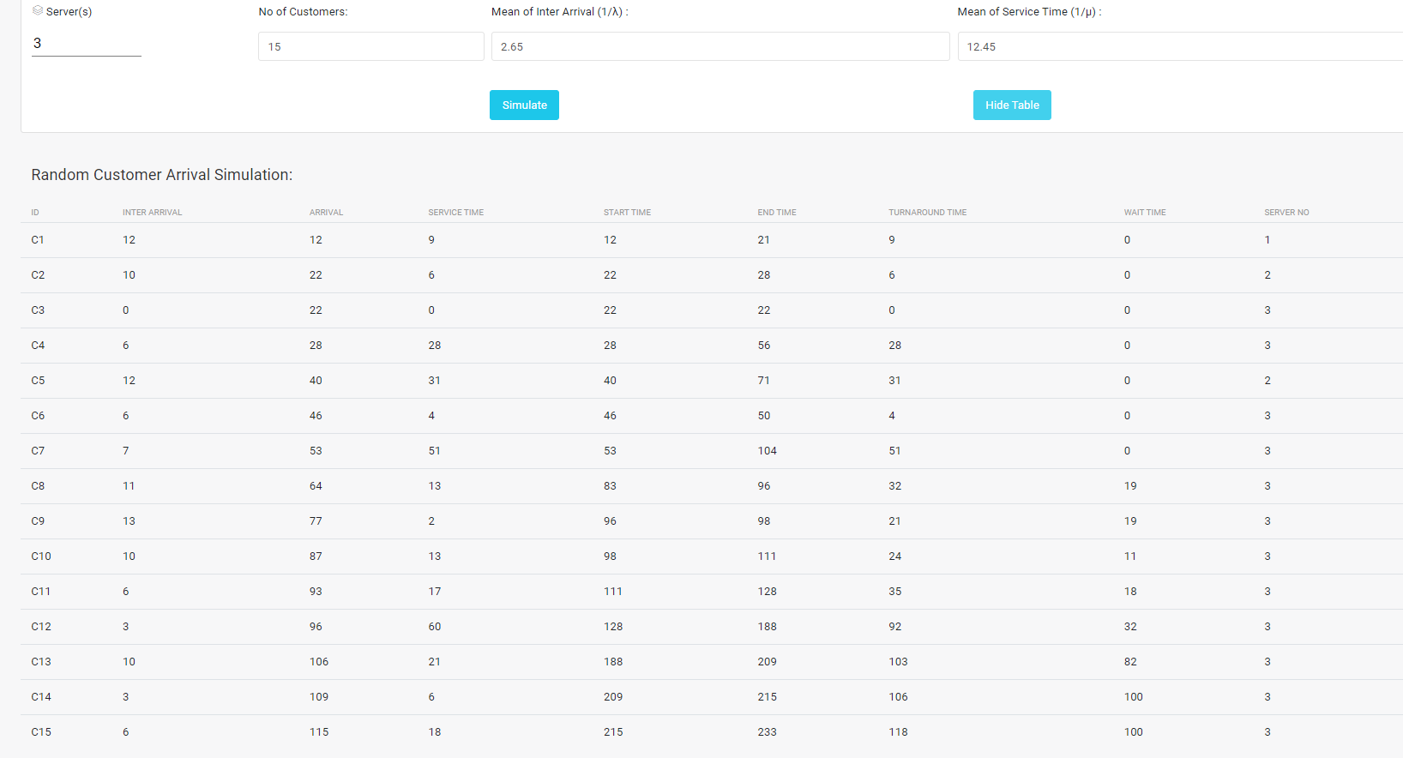

**Source Code:**

***Home Page:***

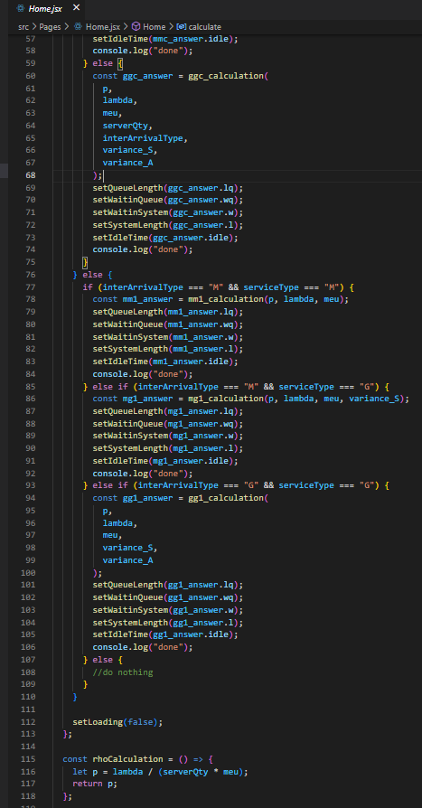

***Excel Upload and Calculation Code***

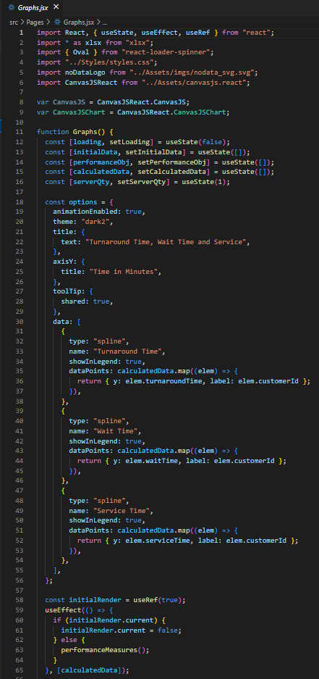

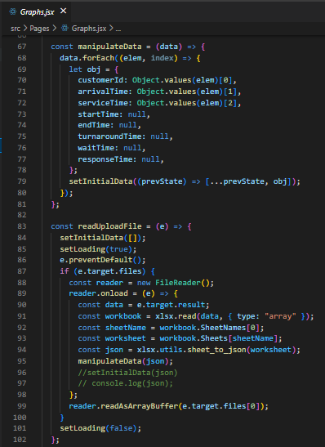

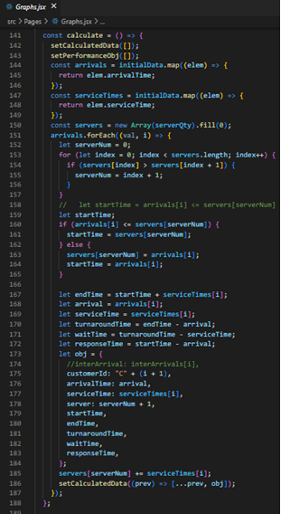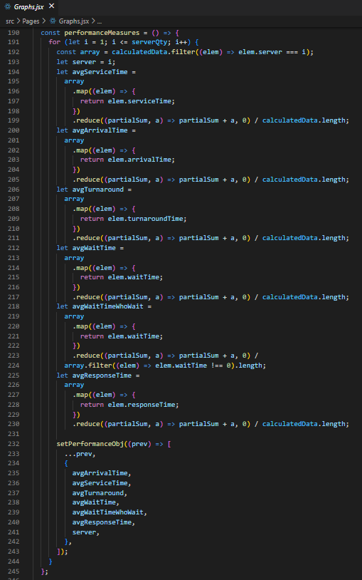

***Random Number and Calculation Code***

